Software Design Document
ONLINE JOB PORTAL SYSTEM



Submitted by
Abdul Saboor (F22BINFT1M01258)

Submitted to
Mr. Muzamil ur Rehman

Department of Information Technology
Faculty of Computing
The Islamia University of Bahawalpur

Summary
The Online Job Portal System is a web-based application developed to modernize and simplify the recruitment process for both job seekers and employers. The system provides a centralized platform where job seekers can explore job opportunities and apply for positions, while employers can efficiently manage job postings and recruitment activities through dedicated dashboards.
The system supports role-based access with two primary user roles: Job Seekers and Employers. Job seekers can register, log in, create and update profiles, upload resumes, search and filter jobs based on categories or skills, and apply for jobs through an intuitive interface. Employers can create company profiles, post and manage job vacancies, view applications, download resumes, and shortlist or reject candidates as part of the hiring process.
The application is developed using HTML, CSS, and JavaScript for the frontend, PHP for server-side processing, and MySQL as the backend database. The system follows a structured design approach with a three-tier architecture to ensure modularity, scalability, and maintainability. Security features such as password hashing, input validation, and role-based authorization are implemented to protect user data and ensure secure system access.
This project aims to reduce manual recruitment efforts, improve communication between employers and job seekers, and provide an efficient and reliable digital hiring platform. The Software Design Document focuses on the internal design, architecture, and implementation details of the system, serving as a technical guideline for development, testing, and future enhancements.

Table of Content
Table of Contents

Table of Content 3
📗 Software Design Document (SDD) 5
Online Job Portal System 5
1. Introduction 6
1.1 Purpose of the Document 6
1.2 Scope of the System 6
1.3 Definitions, Acronyms, and Abbreviations 6
1.4 References 7
1.5 System Overview 7
2. Design Considerations 8
2.1 Design Goals 8
2.2 Assumptions and Constraints 8
2.3 Development Environment 8
3. System Architecture Design 8
3.1 Architectural Overview 8
System Architecture Design 9
Three-Tier Architecture Diagram 9
Deployment Diagram 10
3.2 Technology Stack 11
4. Module Design 11
4.1 Job Seeker Module 11
Job Seeker Module Functional Diagram 11
4.2 Employer Module 12
Employer Module Functional Diagram 12
Job Posting Workflow Diagram 13
4.3 Admin Module 14
5. Database Design 15
5.1 Database Overview 15
Entity Relationship Diagram (ERD) 15
Database Schema Diagram 16
5.2 Table Descriptions 16
6. Class Design 16
6.1 Class Design Overview 16
Diagram represents primary classes of the system: 17
Hierarchy Diagram 17
6.2 Class Responsibilities 18
7. Sequence Design 18
7.1 Sequence Design Overview 18
Login Sequence Diagram 18
User Registration Sequence Diagram 19
Job Application Sequence Diagram 19
Employer Review Application Sequence Diagram 19
8. User Interface Design 20
8.1 UI Design Overview 20
UI Navigation Flow Diagram 20
8.2 Login Interface 21
8.3 Job Seeker Dashboard 21
8.4 Employer Dashboard 21
9. Security Design 21
9.1 Security Design Overview 21
Authentication Flow Diagram 21
Role-Based Access Control (RBAC) Diagram 22
9.2 Data Security 22
9.3 Input Validation 22
10. Error Handling and Validation Design 22
10.1 Error Handling Overview 22
Error Handling Flow Diagram 23
Invalid Login Attempt Diagram 23
10.2 Validation Strategy 23
11. Performance and Scalability Design 24
11.1 Performance Design 24
Request–Response Flow Diagram 24
11.2 Scalability Design 24
Scalability Expansion Diagram 25
12. Conclusion 25
Note: 25
13.References 26

📗 Software Design Document (SDD)

Online Job Portal System

1. Introduction

1.1 Purpose of the Document
This Software Design Document (SDD) is prepared to describe the internal design and technical structure of the Online Job Portal System. The main purpose of this document is to explain how the system is designed, structured, and implemented in order to fulfill the requirements specified in the Software Requirements Specification (SRS).
This document serves as a guideline for developers, testers, and future maintainers by providing a clear understanding of system architecture, modules, data flow, and security mechanisms. Unlike the SRS, which focuses on system requirements, this document focuses on design decisions and implementation logic.

1.2 Scope of the System
The Online Job Portal System is a web-based recruitment platform designed to connect job seekers and employers through a centralized and automated system. The system allows job seekers to search and apply for jobs, while employers can post job vacancies, manage applications, and shortlist candidates efficiently.
The scope of this document includes:
- Overall system architecture
- Module-level design
- Database structure
- Security and validation mechanisms
- Performance and scalability considerations
Business rules and functional requirements are referenced from the SRS and are not repeated in detail in this document.

1.3 Definitions, Acronyms, and Abbreviations
Term | Definition
Problem Statement | A concise description of an issue to be addressed or a condition to be improved upon. It identifies the gap between the current (problem) state and the desired (goal) state of a process or product. The main purpose of the problem statement is to clearly identify and explain the problem. It is referenced throughout the project to maintain focus and ensure alignment with project objectives.
Entry | A single data item that is collected, stored, or delivered within the Online Job Portal system.
Job Provider | A person or organization responsible for managing job postings and recruitment activities within the system.
User | A person who interacts with the system, such as a job seeker, employer, or system administrator.
Research Objective | A clear, concise, and declarative statement that provides direction for investigating variables under study. It defines what a research project aims to achieve and helps measure outcomes such as identification or description of variables.
GUI | Graphical User Interface – a visual interface that allows users to interact with the system using graphical elements such as buttons, forms, and menus.
SRS | Software Requirements Specification – a document that defines the functional and non-functional requirements of the system.
SDD | Software Design Document – a document that describes the internal design, architecture, and implementation details of the system.
C# | C Sharp – a Microsoft programming language used for developing applications.
SQL | Structured Query Language – a standard language used to manage and manipulate relational databases.
OJP | Online Job Portal – the web-based recruitment management system developed in this project.

1.4 References
- IEEE Standard for Software Design Documentation
- PHP Official Documentation
- MySQL Reference Manual

1.5 System Overview
The Online Job Portal System is a browser-based application developed using a client-server model. Users interact with the system through a web interface, while backend services handle request processing, business logic, and database operations. The system provides separate dashboards for job seekers and employers, ensuring role-based access and personalized functionality.

2. Design Considerations

2.1 Design Goals
The system is designed with the following goals:
- To provide a simple and user-friendly interface
- To ensure secure access and data protection
- To follow a modular design for easy maintenance
- To support scalability for future enhancements
The design emphasizes separation of concerns to reduce system complexity.

2.2 Assumptions and Constraints
Assumptions:
- Users will access the system using modern web browsers
- Internet connectivity will be available
Constraints:
- The system must operate within a PHP-supported environment
- MySQL will be used as the database management system

2.3 Development Environment
The development environment consists of widely used web technologies. HTML, CSS, and JavaScript are used for frontend development, PHP is used for server-side logic, and MySQL is used for relational data storage. Apache web server is used for hosting the application.

3. System Architecture Design

3.1 Architectural Overview

The Online Job Portal System follows a three-tier architecture, which divides the system into presentation layer, application layer, and database layer. This architectural approach improves scalability, security, and maintainability by separating user interface, business logic, and data management.

System Architecture Design

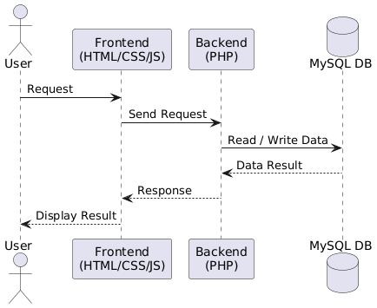

(This diagram illustrates the interaction between frontend, backend, and database layers.)

Three-Tier Architecture Diagram

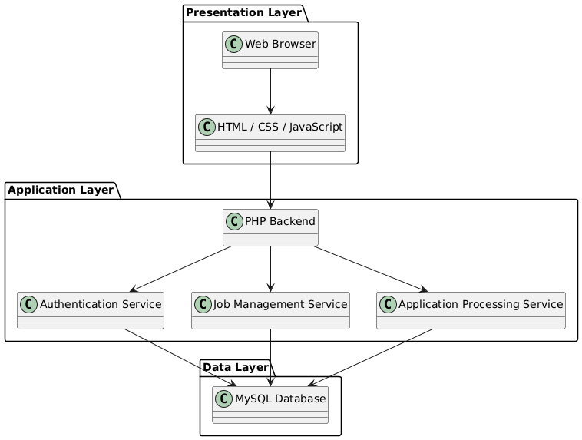
(This diagram shows presentation, application, and data layers in detail.)

Deployment Diagram
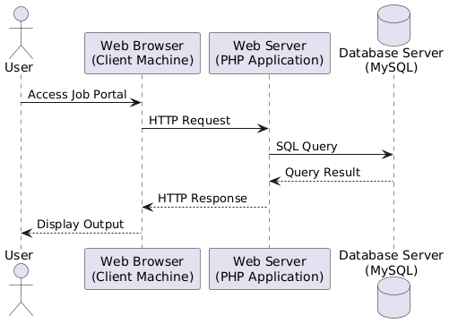
(This diagram represents system deployment across browser, web server, and database server.)

3.2 Technology Stack
- Frontend: HTML, CSS, JavaScript
- Backend: PHP
- Database: MySQL
- Server: Apache
This stack ensures compatibility, reliability, and ease of deployment.

4. Module Design

4.1 Job Seeker Module
The Job Seeker Module is responsible for handling all activities related to job seekers. This module allows users to register, log in, create and update profiles, upload resumes, search for jobs, apply filters, and submit job applications.
The module communicates with job and application components to retrieve job listings and submit application data securely.

Job Seeker Module Functional Diagram
The Job Seeker Module is a core component of the Online Job Portal System that manages all activities related to job seekers. This module is responsible for handling user registration and authentication, profile management, job searching, and job application processes.
It acts as an interface between the job seeker and backend services, ensuring that user requests are processed efficiently and securely.
The following diagram illustrates the internal functional workflow of the Job Seeker Module. It shows how a job seeker interacts with the system, how requests are processed through different services, and how data is stored and retrieved from the database during various operations such as login, job search, and job application submission.

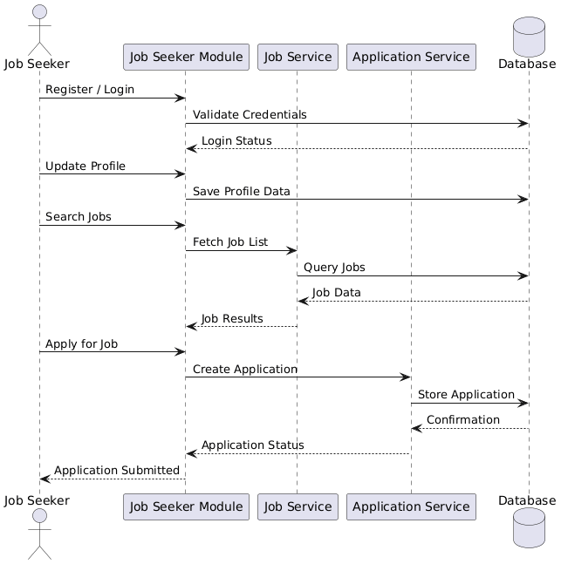
(Shows internal functions of the Job Seeker module.)

4.2 Employer Module
The Employer Module enables employers to manage recruitment activities. Employers can create company profiles, post job vacancies, update or delete listings, review applications, download resumes, and shortlist or reject candidates.
This module provides an efficient workflow for managing hiring processes.

Employer Module Functional Diagram
The Employer Module is designed to support all recruitment-related activities performed by employers within the Online Job Portal System. This module enables employers to manage company profiles, create and publish job postings, review applications submitted by job seekers, and make hiring decisions such as shortlisting or rejecting candidates. The module ensures smooth interaction between the employer and the system while maintaining data accuracy and security.
The following diagram illustrates the functional workflow of the Employer Module. It demonstrates how employers interact with the system, how their requests are processed through backend services, and how application and job-related data is stored and retrieved from the database during various recruitment operations.
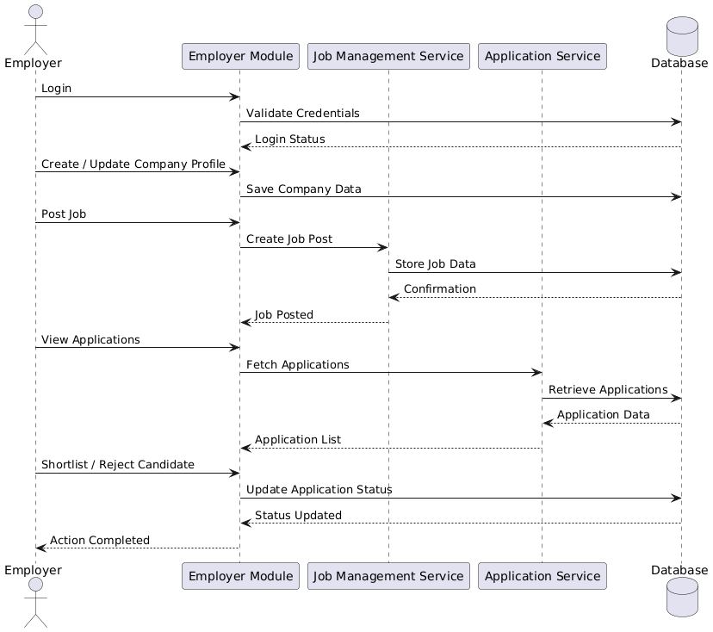\

Job Posting Workflow Diagram

• The Job Posting Workflow defines the complete process through which an employer creates, manages, and updates job vacancies within the Online Job Portal System. It focuses on ensuring that job posting activities are performed in a structured and secure manner.
• The workflow begins with employer authentication, where the system verifies the employer’s login credentials before allowing access to job posting features. This step ensures that only authorized employers can create or manage job listings.
• After successful authentication, the employer initiates the job creation process by entering job-related information such as job title, category, description, required skills, and job status.
• The system performs input validation on the submitted job details to ensure data accuracy, completeness, and consistency before further processing.
• Once validated, the job details are sent to the Job Management Service, which handles the business logic related to job posting and management.
• The validated job information is then stored securely in the database, ensuring that all job records are properly maintained and retrievable.
• The workflow also supports job management activities, allowing employers to update, modify, or manage existing job postings as needed.
• After successful storage or update, the system confirms the action and makes the job listing available to job seekers for searching and applying.
• The interaction between the employer, system modules, and the database ensures data consistency, reliability, and efficient job posting management.
• The following diagram visually represents this workflow by illustrating how job details are processed, saved, updated, and managed within the system.

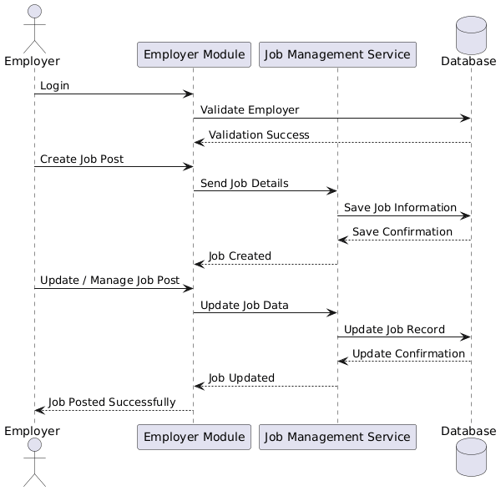
(Illustrates steps involved in job posting and management.)

4.3 Admin Module
The Admin Control Flow represents the administrative operations and monitoring mechanisms of the Online Job Portal System. The administrator plays a critical role in ensuring the smooth functioning, security, and reliability of the system. This module provides centralized control over users, job postings, and system activities, allowing the administrator to maintain platform integrity and operational efficiency.
Through the admin panel, the administrator can authenticate securely, view and manage registered users, monitor job postings created by employers, and oversee overall system activities. The admin is also responsible for handling system-level tasks such as reviewing system logs, monitoring usage statistics, and ensuring that all operations comply with system policies and rules.
The following diagram illustrates the interaction between the administrator, administrative services, and the database during various control and monitoring operations. It shows how administrative requests are processed, how data is retrieved from the database, and how system information is presented to the administrator through the admin dashboard. This flow ensures proper supervision, accountability, and stable system operation.

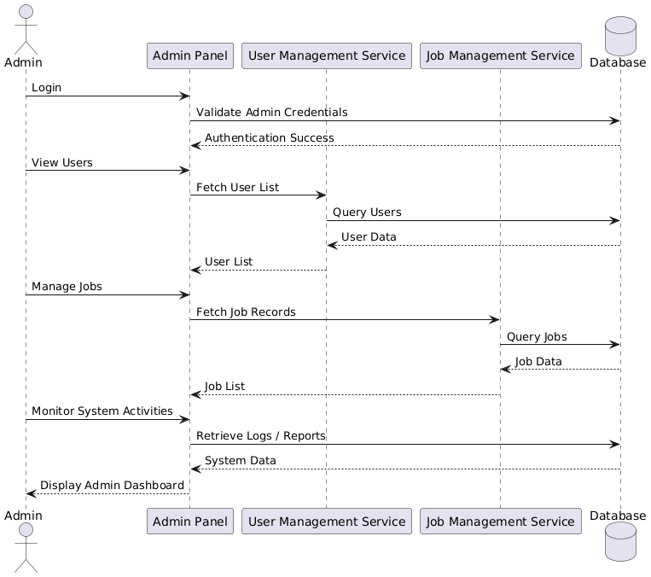

5. Database Design

5.1 Database Overview
The system uses a MySQL relational database to store all system data in a structured and secure manner. The database design follows normalization principles to minimize redundancy and ensure data integrity.

Entity Relationship Diagram (ERD)
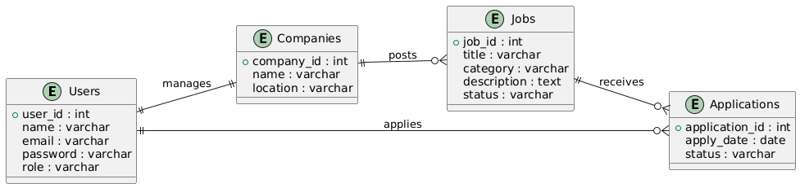
Shows entities such as users, jobs, applications, and companies.

Database Schema Diagram
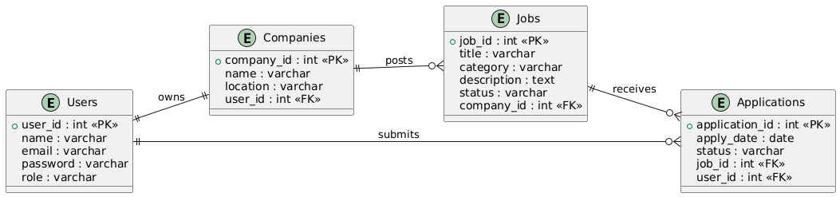
Represents table structures and relationships.

5.2 Table Descriptions
- Users Table: Stores user credentials and roles
- Jobs Table: Contains job posting information
- Applications Table: Stores job application details and status
- Companies Table: Stores employer company data

6. Class Design

6.1 Class Design Overview
The Online Job Portal System is designed using object-oriented programming (OOP) principles to ensure modularity, reusability, and maintainability. Each major system entity is represented as a class that encapsulates its data and related behavior.
The class design helps developers understand how different system components are structured and how they interact internally.

Diagram represents primary classes of the system:
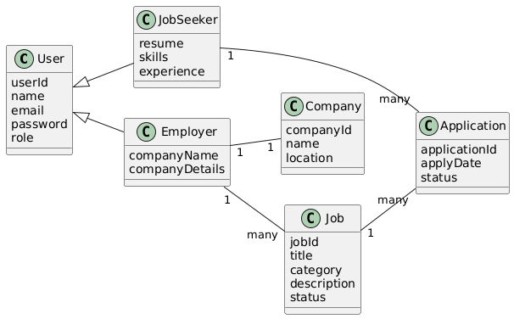
This diagram represents the primary classes of the system such as User, JobSeeker, Employer, Job, Application, and Company along with their relationships.

Hierarchy Diagram
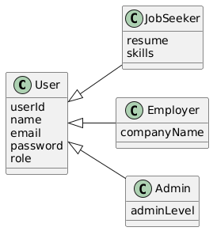
This diagram shows inheritance where User is a parent class and JobSeeker, Employer, and Admin are derived classes.

6.2 Class Responsibilities
Each class in the system has a clearly defined responsibility:
- User Class: Handles authentication and common user attributes
- JobSeeker Class: Manages job seeker profile, resume, and applications
- Employer Class: Manages company profile and job postings
- Job Class: Stores job-related information
- Application Class: Handles job application status and tracking
This separation ensures clean code structure and easier debugging.

7. Sequence Design

7.1 Sequence Design Overview
Sequence diagrams are used to represent interaction between system components over time. These diagrams explain how different objects communicate with each other to complete a specific task.

Login Sequence Diagram
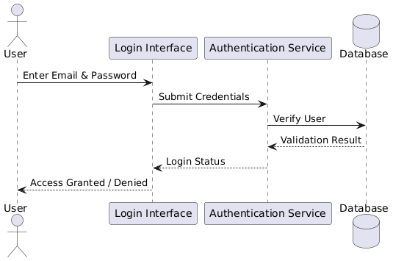
Illustrates the interaction between user, system, and database during login.

User Registration Sequence Diagram
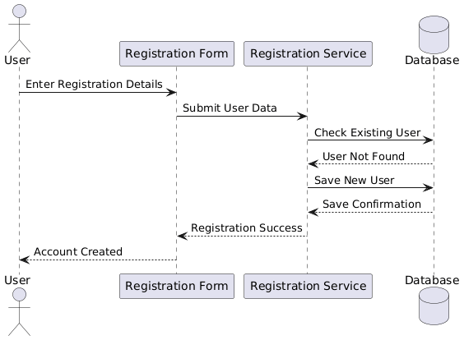
Shows step-by-step interaction for new user registration.

Job Application Sequence Diagram
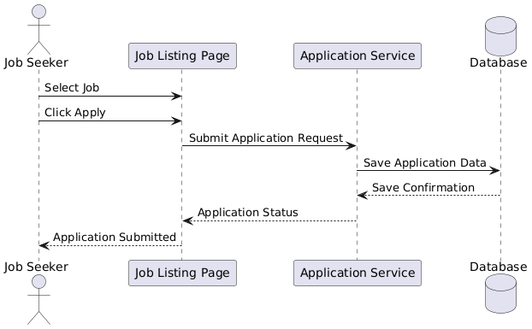
Shows how a job seeker applies for a job and how data is stored.

Employer Review Application Sequence Diagram
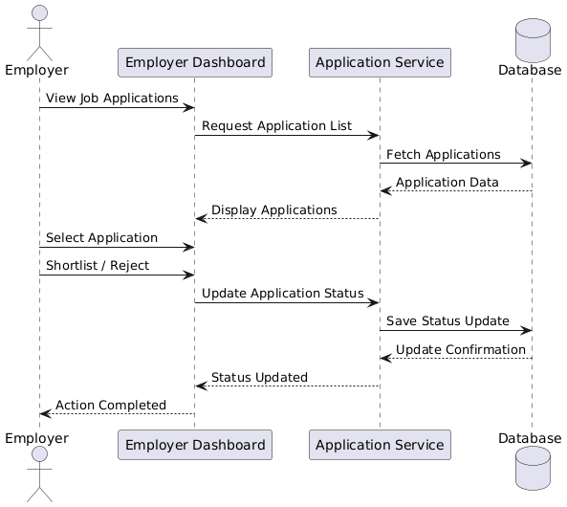
Represents how employers view and manage applications.

8. User Interface Design

8.1 UI Design Overview
The user interface is designed to be simple, responsive, and user-friendly. The system provides separate dashboards for job seekers and employers to ensure clarity and ease of use.
The UI design focuses on reducing user effort and improving navigation efficiency.

UI Navigation Flow Diagram
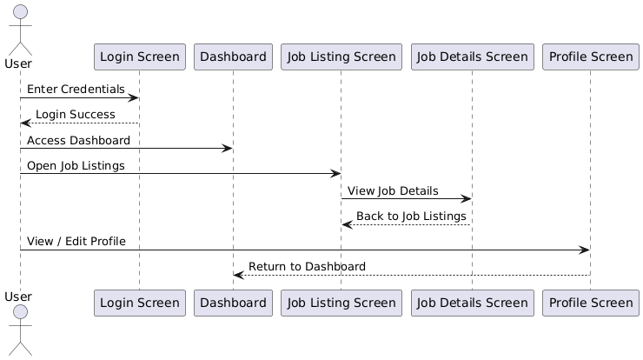
Shows navigation between different screens of the system.

8.2 Login Interface
The login interface allows users to securely access the system using their credentials. Based on the user role, the system redirects users to the appropriate dashboard after successful authentication.

8.3 Job Seeker Dashboard
The job seeker dashboard displays personalized information such as applied jobs, profile completion status, and recommended job listings.

8.4 Employer Dashboard
The employer dashboard provides access to job postings, applicant lists, and application management features, enabling efficient recruitment workflows.

9. Security Design

9.1 Security Design Overview
Security is a critical part of the system design. The Online Job Portal System implements multiple security mechanisms to protect user data and ensure secure system access.

Authentication Flow Diagram
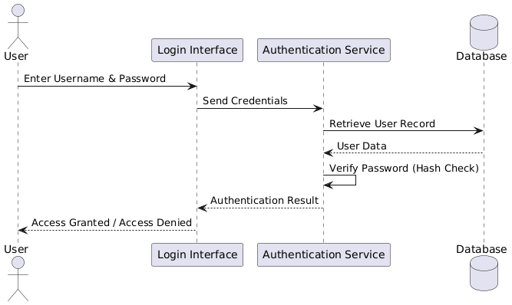
Shows secure login and authentication process.

Role-Based Access Control (RBAC) Diagram

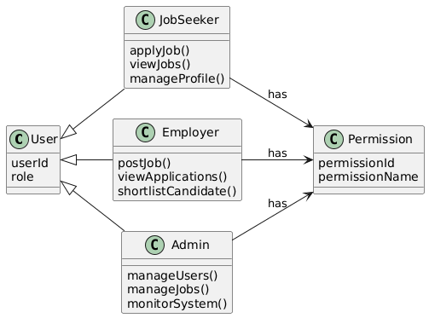
Illustrates access permissions based on user roles.

9.2 Data Security
User passwords are stored in hashed form, and secure database queries are used to prevent SQL injection attacks. Sensitive data is protected during transmission and storage.

9.3 Input Validation
All user inputs are validated on both client-side and server-side to prevent invalid or malicious data from entering the system.

10. Error Handling and Validation Design

10.1 Error Handling Overview
The system is designed to handle errors gracefully without exposing technical details to users. Error handling improves system reliability and user experience.

Error Handling Flow Diagram
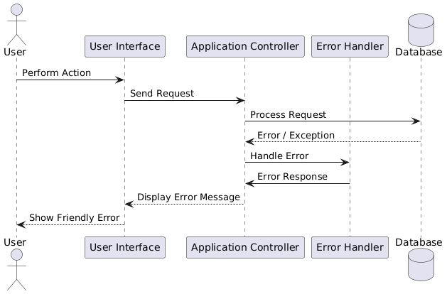
Shows how system detects and handles errors.

Invalid Login Attempt Diagram
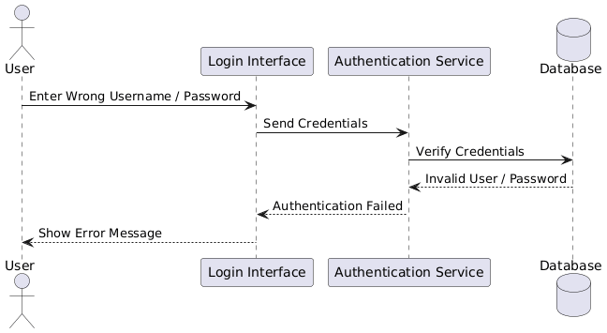
Illustrates handling of incorrect credentials.

10.2 Validation Strategy
Validation checks are applied for:
- Empty form fields
- Duplicate email entries
- Invalid input formats
Clear error messages are displayed to guide users.

11. Performance and Scalability Design

11.1 Performance Design
The system uses optimized database queries and efficient server-side processing to ensure fast response times even under multiple user requests.

Request–Response Flow Diagram
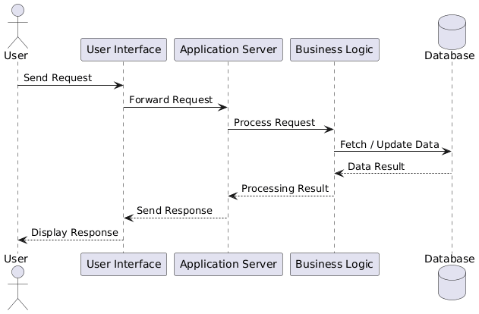
Shows how user requests are processed and responses returned.

11.2 Scalability Design
The modular architecture allows the system to scale horizontally by adding new features or supporting more users without major design changes.

Scalability Expansion Diagram
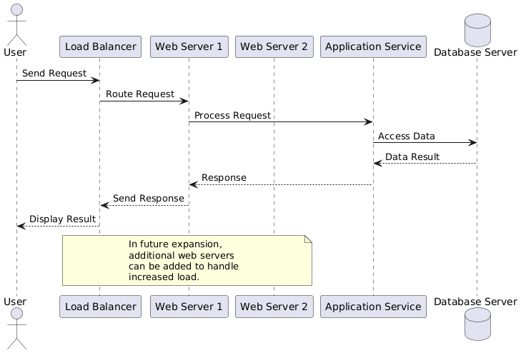
Represents future system expansion strategy.

12. Conclusion
This Software Design Document provides a comprehensive and detailed description of the internal design of the Online Job Portal System. The document explains the system architecture, module design, database structure, security mechanisms, and performance considerations.
This SDD serves as a strong foundation for system implementation, testing, maintenance, and future enhancements by clearly defining how the system is designed and how it operates internally.

Note:
Functional and non-functional requirements are defined in the SRS document. This Software Design Document focuses on the technical design, internal structure, and implementation approach of the system.

13.References

[1] IEEE Computer Society, IEEE Standard for Software Design Descriptions, IEEE Std 1016-2009, 2009.
[2] I. Sommerville, Software Engineering, 10th ed., Pearson Education, 2016.
[3] PHP Group, “PHP Manual,” [Online]. Available: https://www.php.net/manual/en/. [Accessed: Jan. 2026].
[4] Oracle Corporation, “MySQL Reference Manual,” [Online]. Available: https://dev.mysql.com/doc/. [Accessed: Jan. 2026].
[5] Object Management Group (OMG), Unified Modeling Language (UML) Specification, Version 2.5, 2015.
[6] PlantUML, “PlantUML Language Reference Guide,” [Online]. Available: https://plantuml.com/. [Accessed: Jan. 2026].
[7] World Wide Web Consortium (W3C), “HTML, CSS, and JavaScript Documentation,” [Online]. Available: https://www.w3.org/. [Accessed: Jan. 2026].

